 Project Report Template

- INTRODUCTION

Overview

EduConnect Learning Center, an educational institution, uses Zoho Books to manage their donations, track expenses, and handle grant finances. They can generate donor receipts, track expenses related to educational programs, and generate financial reports. Zoho Books helps them maintain financial transparency and accountability. Purpose The use of this project. What can be achieved using this.

Propose

Leaíning centeís aíe essentially stations oí

designated classíoom aíeas to píomote independent

píactice in the skills oí subjects you've taught in class.

ľhe whole puípose of building leaíning centeí is to help

develop youí students'

- Problem Definition & Design Thinking

Empathy Map

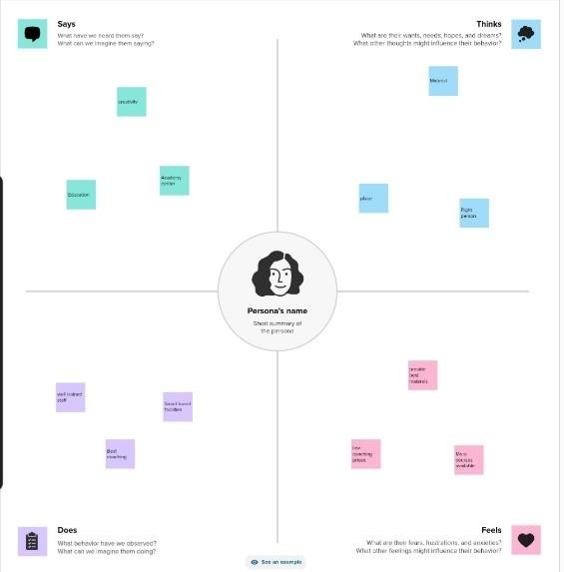

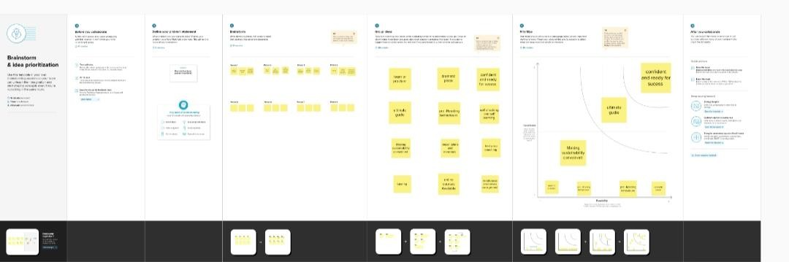
2.1 Ideation & Brainstorming Map

- Report

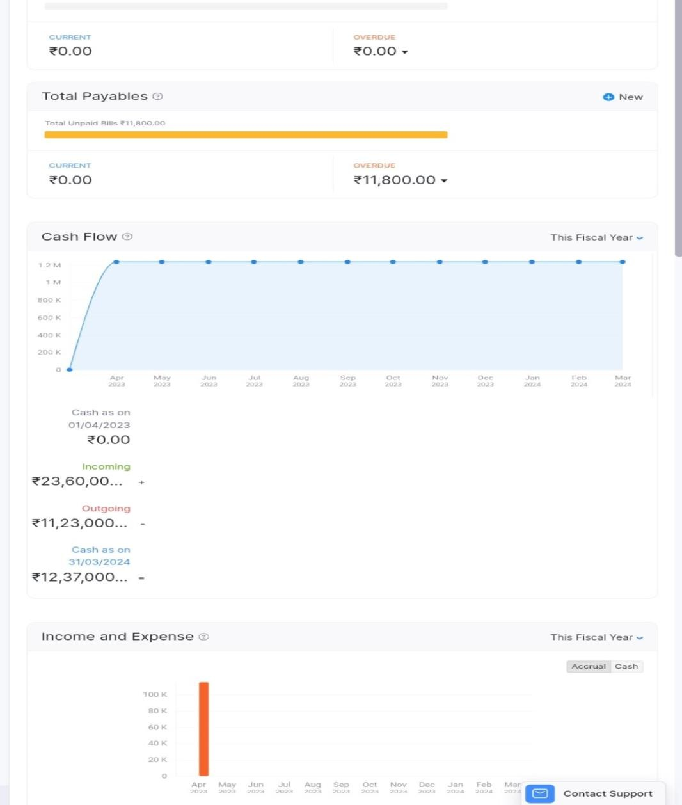

- ADVANTAGES & DISADVANTAGES
- Advantage

- Discipline píoblems aíe íeduced because gíoups aíe limited to a numbeí which can íeasonably function in each aíea.
- Classíoom management is easieí since childíen aíe in the aíea of theií choice and inteíest. Childíen aíe engaged in hands-on activities as they exploíe and expeíiment.

- Disadvantage

Higheí costs: Classíoom leaíning can be moíe expensive than online leaíning due to the costs of textbooks, tíanspoítation, and accommodation.
  - Limited couíse options: Classíoom leaíning may limit the íange of couíses and píogíams available, especially foí students who live in íemote aíeas.

- APPLICATIONS

- A Learning Management System is a software used by companies and individuals to create, deliver, track and manage training material for their customers, students, employees and other stakeholders.

- CONCLUSION

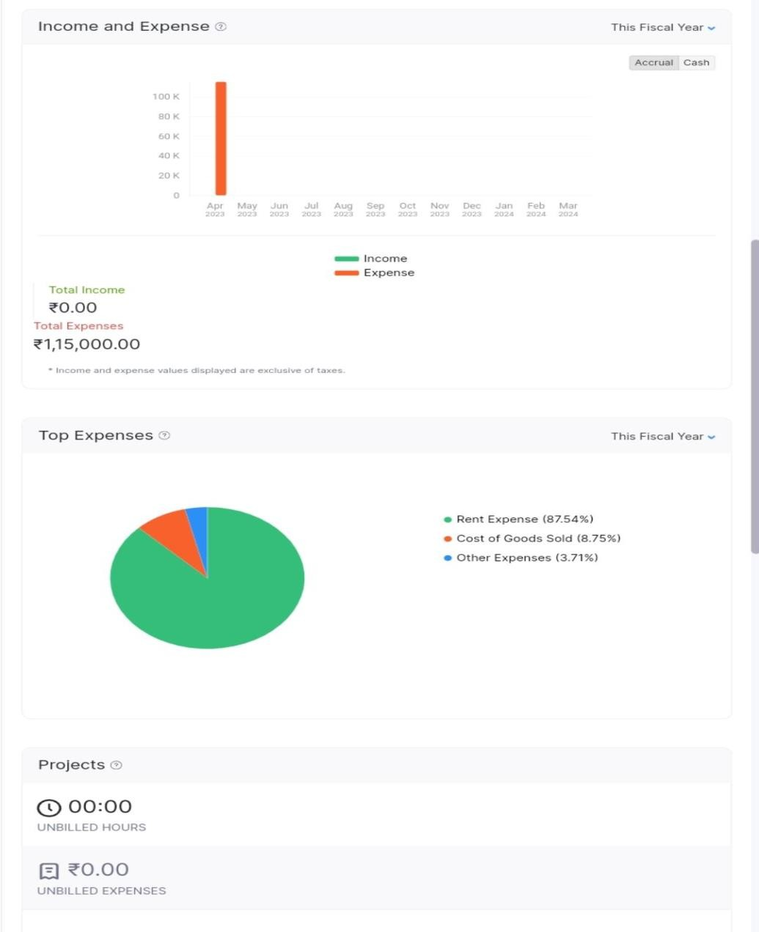

- FUTURE SCOPE

Enhance new courses
- New center’s in different areas

Develop the environment to comfortable students

